How to configure the Wi-Fi function for the F4 vista

Before configuration
The F4 vista serve as a station in the wireless network, before the F4 vista apply to Network, another physical component of that 802.11 network consist Distribution system, Access Point, Wireless Medium must exist.
You must know the ESSID (name of network) of local network you want to connect to.

Operation step
Step 1. Copy the file WiFiConfigure that is along with the product provided by the manufacturer in the PC.
Step 2. Connect the F4 Vista fingerprint machine with the PC over the Ethernet or RS 232
Step 3. Double-click ZKMACUpdata to open this file, the following windowing appear.
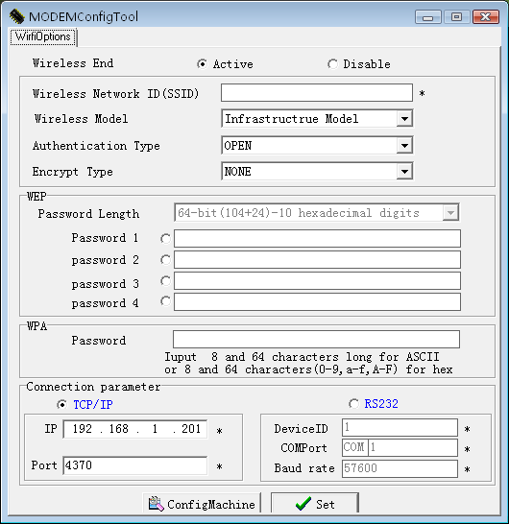

Step 4.Activate the software
There are two options Active, Disable on the interface, for wireless End (station) the two options must to be set down.
If you select the Active item, this wireless-end will be activated, you can configure the AP (Access Point) of 802.11 network..
If you select the Disable, this wireless-end will be invalid, you can set the connection way of the fingerprint machine, and its configuration of IP address.

Step5 Confirm Network ID
Full the blank of local wireless Network ID you want to connect with any character or figure ( capital letter and small letter is different)
Note: must fulfill the blank that is marked with“*”

Step6 Determine Network model
there are two option , Infrastructure Model, and Ad－hoc Model, shown as following figure
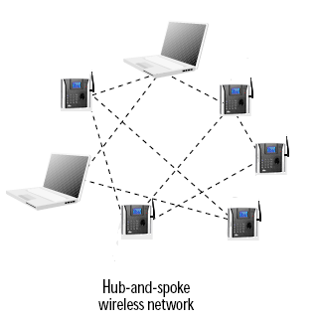

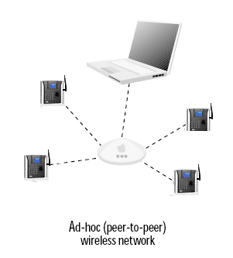
click the draw –down box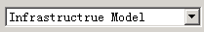 to select the wireless network model, depending on the different topology of network, this Infrastructure Model will apply to Hub and Spoke wireless network, the Ad－hoc Model is used in the peer to peer wireless network..

Step 7.Select the Authentication Type,
the Infrastructure Model include five Authentication Type that are OPEN 、SHARED、 WEPAUTO、 WPAPSK、 WPA2PS.
the Ad－hoc Model include OPEN 、SHARED、 WEPAUTO、WPANONE four type of Authentication Type.
Click the draw-down box to select the Authentication Type

Step 8.Select Encrypt Type
When the item NONE of encrypt Type is selected, then the password in WEP (Wired equivalent privacy) and WPA (WiFi protested access) item is not permitted to modify it, it is not need to input password too.
According to Authentication Type, and Encrypt Type ,Click draw down box to input the password, password comply with the criterion set down by the software.
Note: there are four group passwords in the WEP column, till the all password have been set up is correct, the current password is valid

Step 9Set Connection Parameter
The fingerprint machine fully support two connection ways, one TCP/IP, anther one is RS 232,.
If you select TCP/IP, here the IP and Port value must to be assigned, its value is same with one in the communication option of the fingerprint machine. Set the option Ethernet in the fingerprint machine to “Yes”.
If you selectRS232, must configure these parameter ,DeviceID、COMPort、Baud rate same with one in the communication option of the fingerprint machine.

Step10. Configure the wireless Network IP address
Click configMchine this button, the following menu will pop-up
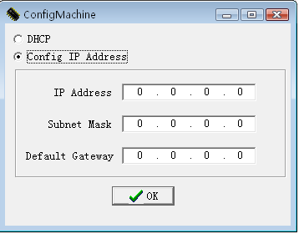
If there is the DHCP function in the 802.11 network Distribution system , you may choose DHCP, press OK to exit.
Otherwise, full the IP Address，Subnet Mask blank with the correct figure, press OK to exit to main interface.
After all setting for wireless network is completed, single –click SETbutton on the MODEMConfigTool interface, the prompt “ in working” will appear on the fingerprint machine.
After configure successfully, the corresponding message will inform you, click OK to close the message.
Be sure to shut down and restart the machine, so the configureation change take effect.

View the fingerprint machine Wireless Setting
You can view the fingerprint machine Wireless Setting to get the information of the wireless network communication
Power on the Fingerprint Machine, press menu → System Info→ Dev Info →wirlesscard→rausb0:

